Project 3: Logic and Classical Planning
Due: Sunday, January 04, 11:59 PM PT.

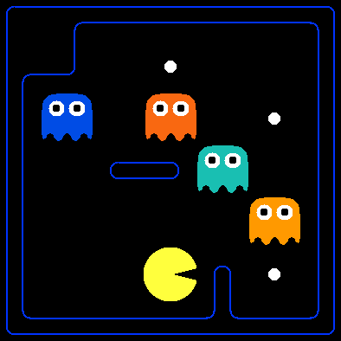
Logical Pacman,
Food is good AND ghosts are bad,
Spock would be so proud

Table of contents
- Introduction
- The Expr Class
  - A note on conjoin and disjoin
- Prop Symbol Names (Important!)
  - Rules
  - Pacphysics symbols
- SAT Solver Setup
- Q1 (2 points): Logic Warm-up
- Q2 (2 points): Logic Workout
- Q3 (4 points): Pacphysics and Satisfiability
- Q4 (3 points): Path Planning with Logic
- Q5 (3 points): Eating All the Food
- Helper Functions for the rest of the Project
  - Add pacphysics, action, and percept information to KB
  - Find possible pacman locations with updated KB
  - Find provable wall locations with updated KB
- Q6 (4 points): Localization
- Q7 (3 points): Mapping
- Q8 (4 points): SLAM
- Submission

Introduction
n this project, you will use/write simple Python functions that generate logical sentences describing Pacman physics, aka pacphysics. Then you will use a SAT solver, pycosat, to solve the logical inference tasks associated with planning (generating action sequences to reach goal locations and eat all the dots), localization (finding oneself in a map, given a local sensor model), mapping (building the map from scratch), and SLAM (simultaneous localization and mapping).
As in previous programming assignments, this assignment includes an autograder for you to grade your answers on your machine. This can be run with the command:
python autograder.py
The code for this project contains the following files, available as a zip archive.
Files you'll edit:
logicPlan.py | Where you will put your code for the various logical agents.
Files you might want to look at:
logic.py | Propsitional logic code originally from aima-python with modifications for our project. There are several useful utility functions for working with logic in here.
logicAgents.py | The file that defines in logical planning form the two specific problems that Pacman will encounter in this project.
pycosat_test.py | Quick test main function that checks that the pycosat module is installed correctly.
game.py | The internal simulator code for the Pacman world. The only thing you might want to look at in here is the Grid class.
test_cases/ | Directory containing the test cases for each question.
Supporting files you can ignore:
pacman.py | The main file that runs Pacman games.
logic_util.py | Utility functions for logic.py.
util.py | Utility functions primarily for other projects.
logic_planTestClasses.py | Project specific autograding test classes.
graphicsDisplay.py | Graphics for Pacman.
graphicsUtils.py | Support for Pacman graphics.
textDisplay.py | ASCII graphics for Pacman.
ghostAgents.py | Agents to control ghosts.
keyboardAgents.py | Keyboard interfaces to control Pacman.
layout.py | Code for reading layout files and storing their contents.
autograder.py | Project autograder.
testParser.py | Parses autograder test and solution files.
testClasses.py | General autograding test classes.
Files to Edit and Submit: You will fill in portions of logicPlan.py during the assignment. Once you have completed the assignment, you will submit these files to Gradescope (for instance, you can upload all .py files in the folder). Please do not change the other files in this distribution.
Evaluation: Your code will be autograded for technical correctness. Please do not change the names of any provided functions or classes within the code, or you will wreak havoc on the autograder. However, the correctness of your implementation – not the autograder’s judgements – will be the final judge of your score. If necessary, we will review and grade assignments individually to ensure that you receive due credit for your work.
Academic Dishonesty: We will be checking your code against other submissions in the class for logical redundancy. If you copy someone else’s code and submit it with minor changes, we will know. These cheat detectors are quite hard to fool, so please don’t try. We trust you all to submit your own work only; please don’t let us down. If you do, we will pursue the strongest consequences available to us.
Getting Help: You are not alone! If you find yourself stuck on something, contact the course staff for help. Office hours, section, and the discussion forum are there for your support; please use them. If you can’t make our office hours, let us know and we will schedule more. We want these projects to be rewarding and instructional, not frustrating and demoralizing. But, we don’t know when or how to help unless you ask.
Discussion: Please be careful not to post spoilers.

The Expr Class
In the first part of this project, you will be working with the Expr class defined in logic.py to build propositional logic sentences. An Expr object is implemented as a tree with logical operators (∧∧, ∨∨, ¬¬, →→, ↔↔) at each node and with literals (AA, BB, CC) at the leaves. Here is an example sentence and its representation:
(A∧B)↔(¬C∨D)(A∧B)↔(¬C∨D)
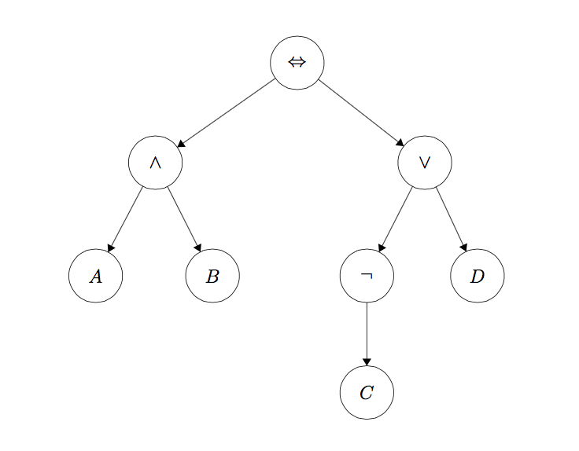
To instantiate a symbol named 'A', call the constructor like this:
A = Expr('A')
The Expr class allows you to use Python operators to build up these expressions. The following are the available Python operators and their meanings:
- ~A: ¬A¬A
- A & B: A∧BA∧B
- A | B: A∨BA∨B
- A >> B: A→BA→B
- A % B: A↔BA↔B
So to build the expression A∧BA∧B, you would type this:
A = Expr('A')
B = Expr('B')
a_and_b = A & B
(Note that A to the left of the assignment operator in that example is just a Python variable name, i.e. symbol1 = Expr('A') would have worked just as well.)
A note on conjoin and disjoin
One last important thing to note is that you must use conjoin and disjoin operators wherever possible. conjoin creates a chained & (logical AND) expression, and disjoin creates a chained | (logical OR) expression. Let’s say you wanted to check whether conditions A, B, C, D, and E are all true. The naive way to achieve this is writing condition = A & B & C & D & E, but this actually translates to ((((A & B) & C) & D) & E), which creates a very nested logic tree (see (1) in diagram below) and becomes a nightmare to debug. Instead, conjoin makes a flat tree (see (2) in diagram below).
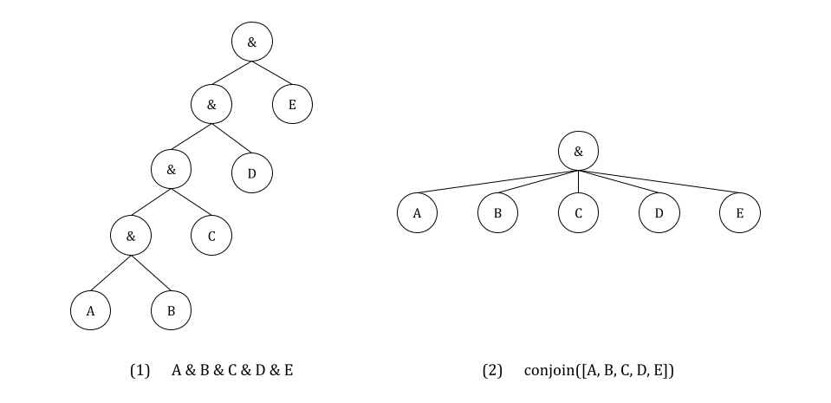

Prop Symbol Names (Important!)
For the rest of the project, please use the following variable naming conventions:
Rules
- When we introduce variables, they must start with an upper-case character (including Expr).
- Only these characters should appear in variable names: A-Z, a-z, 0-9, _, ^, [, ].
- Logical connective characters (&, |) must not appear in variable names. So, Expr('A & B') is illegal because it attempts to create a single constant symbol named 'A & B'. We would use Expr('A') & Expr('B') to make a logical expression.
Pacphysics symbols
- PropSymbolExpr(pacman_str, x, y, time=t): whether or not Pacman is at (x,y)(x,y) at time tt, writes P[x,y]_t.
- PropSymbolExpr(wall_str, x, y): whether or not a wall is at (x,y)(x,y), writes WALL[x,y].
- PropSymbolExpr(action, time=t): whether or not pacman takes action action at time tt, where action is an element of DIRECTIONS, writes i.e. North_t.
- In general, PropSymbolExpr(str, a1, a2, a3, a4, time=a5) creates the expression str[a1,a2,a3,a4]_a5 where str is just a string.
There is additional, more detailed documentation for the Expr class in logic.py.

SAT Solver Setup
A SAT (satisfiability) solver takes a logic expression which encodes the rules of the world and returns a model (true and false assignments to logic symbols) that satisfies that expression if such a model exists. To efficiently find a possible model from an expression, we take advantage of the pycosat module, which is a Python wrapper around the picoSAT library.
Unfortunately, this requires installing this module/library on each machine. In the command line, run pip install pycosat, or pip3 install pycosat on some setups, or conda install pycosat for conda.
On Windows, if you are getting an error message saying error: Microsoft Visual C++ 14.0 or greater is required. Get it with "Microsoft Build Tools": ..., you will have to install a C/C++ compiler following that link; or, use conda install pycosat, for which you will need to have Anaconda installed (recommend uninstalling current Python before installing a new one) and run this from the Anaconda prompt.
Testing pycosat installation:
After unzipping the project code and changing to the project code directory, run:
python pycosat_test.py
This should output:
[1, -2, -3, -4, 5]
Please let us know if you have issues with this setup. This is critical to completing the project, and we don’t want you to spend your time fighting with this installation process.

Q1 (2 points): Logic Warm-up
This question will give you practice working with the Expr data type used in the project to represent propositional logic sentences. You will implement the following functions in logicPlan.py:
- sentence1(): Create one Expr instance that represents the proposition that the following three sentences are true. Do not do any logical simplification, just put them in a list in this order, and return the list conjoined. Each element of your list should correspond to each of the three sentences.
A∨BA∨B¬A↔(¬B∨C)¬A↔(¬B∨C)¬A∨¬B∨C¬A∨¬B∨C
- sentence2(): Create one Expr instance that represents the proposition that the following four sentences are true. Again, do not do any logical simplification, just put them in a list in this order, and return the list conjoined.
C↔(B∨D)C↔(B∨D)A→(¬B∧¬D)A→(¬B∧¬D)¬(B∧¬C)→A¬(B∧¬C)→A¬D→C¬D→C
- sentence3(): Using the PropSymbolExpr constructor, create the symbols 'PacmanAlive_0', 'PacmanAlive_1', 'PacmanBorn_0', and 'PacmanKilled_0' (hint: recall that PropSymbolExpr(str, a1, a2, a3, a4, time=a5) creates the expression str[a1,a2,a3,a4]_a5 where str is a string; you should make some strings for this problem to match these exactly). Then, create one Expr instance which encodes the following three English sentences as propositional logic in this order without any simplification:
  - Pacman is alive at time 1 if and only if he was alive at time 0 and he was not killed at time 0 or he was not alive at time 0 and he was born at time 0.
  - At time 0, Pacman cannot both be alive and be born.
  - Pacman is born at time 0.
- findModelUnderstandingCheck():
  - Look at how the findModel(sentence) method works: it uses to_cnf to convert the input sentence into Conjunctive Normal Form (the form required by the SAT solver), and passes it to the SAT solver to find a satisfying assignment to the symbols in sentence, i.e., a model. A model is a dictionary of the symbols in your expression and a corresponding assignment of True or False. Test your sentence1(), sentence2(), and sentence3() with findModel by opening an interactive session in Python and running from logicPlan import * and findModel(sentence1()) and similar queries for the other two. Do they match what you were expecting?
  - Based on the above, fill in findModelUnderstandingCheck so that it returns what findModel(Expr('a')) would return if lower case variables were allowed. You should not use findModel or Expr beyond what’s already given; simply directly recreate the output.
- entails(premise, conclusion): Return True if and only if the premise entails the conclusion. Hint: findModel is helpful here; think about what must be unsatisfiable in order for the entails to be True, and what it means for something to be unstatisfiable.
- plTrueInverse(assignments, inverse_statement): Returns True if and only if the (not inverse_statement) is True given assignments.
Before you continue, try instantiating a small sentence, e.g. A∧B→CA∧B→C, and call to_cnf on it. Inspect the output and make sure you understand it (refer to AIMA section 7.5.2 for details on the algorithm to_cnf implements).
To test and debug your code run:
python autograder.py -q q1

Q2 (2 points): Logic Workout
Implement the following three functions in logicPlan.py (remembering to use conjoin and disjoin whenever possible):
- atLeastOne(literals): Return a single expression (Expr) in CNF that is true only if at least one expression in the input list is true. Each input expression will be a literal.
- atMostOne(literals): Return a single expression (Expr) in CNF that is true only if at most one expression in the input list is true. Each input expression will be a literal. Hint: Use itertools.combinations. If you have nn literals, and at most one is true, your resulting CNF expression should be a conjunction of (n2)(2n​) clauses.
- exactlyOne(literals): Use atLeastOne and atMostOne to return a single expression (Expr) in CNF that is true only if exactly one expression in the input list is true. Each input expression will be a literal.
Each of these methods takes a list of Expr literals and returns a single Expr expression that represents the appropriate logical relationship between the expressions in the input list. An additional requirement is that the returned Expr must be in CNF (conjunctive normal form). You may NOT use the to_cnf function in your method implementations (or any of the helper functions logic.eliminate_implications, logic.move_not_inwards, and logic.distribute_and_over_or).
Don’t run to_cnf on your knowledge base when implementing your planning agents in later questions. This is because to_cnf makes your logical expression much longer sometimes, so you want to minimize this effect; findModel does this as needed. In later questions, reuse your implementations for atLeastOne(.), atMostOne(.), and exactlyOne(.) instead of re-engineering these functions from scratch. This avoids accidentally making unreasonably slow non-CNF-based implementations.
You may utilize the logic.pl_true function to test the output of your expressions. pl_true takes an expression and a model and returns True if and only if the expression is true given the model.
To test and debug your code run:
python autograder.py -q q2

Q3 (4 points): Pacphysics and Satisfiability
In this question, you will implement the basic pacphysics logical expressions, as well as learn how to prove where pacman is and isn’t by building an appropriate knowledge base (KB) of logical expressions.
Implement the following functions in logicPlan.py:
- pacmanSuccessorAxiomSingle – this generates an expression defining the sufficient and necessary conditions for Pacman to be at (x,y)(x,y) at tt:
  - Read the construction of possible_causes provided.
  - You need to fill out the return statement, which will be an Expr. Make sure to use disjoin and conjoin where appropriate. Looking at SLAMSuccessorAxiomSingle may be helpful, although note that the rules there are more complicated than in this function. The simpler side of the biconditional should be on the left for autograder purposes.
- pacphysicsAxioms – here, you will generate a bunch of physics axioms. For timestep tt:
  - Arguments:
    - Required: t is time, all_coords and non_outer_wall_coords are lists of (x,y)(x,y) tuples.
    - Possibly-None: You will be using these to call functions, not much logic is required.
      - walls_grid is only passed through to successorAxioms and describes (known) walls.
      - sensorModel(t: int, non_outer_wall_coords) -> Expr returns a single Expr describing observation rules; you can take a look at sensorAxioms and SLAMSensorAxioms to see examples of this.
      - successorAxioms(t: int, walls_grid, non_outer_wall_coords) -> Expr describes transition rules, e.g. how previous locations and actions of Pacman affect the current location; we have seen this in the functions in pacmanSuccessorAxiomSingle.
  - Algorithm:
    - For all (x,y)(x,y) in all_coords, append the following implication (if-then form): if a wall is at (x,y)(x,y), then Pacman is not at (x,y)(x,y) at tt.
    - Pacman is at exactly one of the non_outer_wall_coords at timestep tt.
    - Pacman takes exactly one of the four actions in DIRECTIONS at timestep tt.
    - Sensors: append the result of sensorAxioms. All callers except for checkLocationSatisfiability make use of this; how to handle the case where we don’t want any sensor axioms added is up to you.
    - Transitions: append the result of successorAxioms. All callers will use this.
    - Add each of the sentences above to pacphysics_sentences. As you can see in the return statement, these will be conjoined and returned.
  - Function passing syntax:
    - Let def myFunction(x, y, t): return PropSymbolExpr('hello', x, y, time=t) be a function we want to use.
    - Let def myCaller(func: Callable): ... be the caller that wants to use a function.
    - We can pass the function in: myCaller(myFunction). Note that myFunction is not called with () after it.
    - We can use myFunction by having inside myCaller this: useful_return = func(0, 1, q).
- checkLocationSatisfiability – given a transition (x0_y0, action0, x1_y1), action1, and a problem, you will write a function that will return a tuple of two models (model1, model2):
  - In model1, Pacman is at (x1,y1)(x1,y1) at time t=1t=1 given x0_y0, action0, action1. This model proves that it’s possible that Pacman there. Notably, if model1 is False, we know Pacman is guaranteed to NOT be there.
  - In model2, Pacman is NOT at (x1,y1)(x1,y1) at time t=1t=1 given x0_y0, action0, action1. This model proves that it’s possible that Pacman is not there. Notably, if model2 is False, we know Pacman is guaranteed to be there.
  - action1 has no effect on determining whether the Pacman is at the location; it’s there just to match your solution to the autograder solution.
  - To implement this problem, you will need to add the following expressions to your KB:
    - Add to KB: pacphysics_axioms(...) with the appropriate timesteps. There is no sensorModel because we know everything about the world. Where needed, use allLegalSuccessorAxioms for transitions since this is for regular Pacman transition rules.
    - Add to KB: Pacman’s current location (x0,y0)(x0,y0)
    - Add to KB: Pacman takes action0
    - Add to KB: Pacman takes action1
  - Query the SAT solver with findModel for two models described earlier. The queries should be different; for a reminder on how to make queries see entails.
Reminder: the variable for whether Pacman is at (x,y)(x,y) at time tt is PropSymbolExpr(pacman_str, x, y, time=t), wall exists at (x,y)(x,y) is PropSymbolExpr(wall_str, x, y), and action is taken at tt is PropSymbolExpr(action, time=t).
To test and debug your code run:
python autograder.py -q q3

Q4 (3 points): Path Planning with Logic
Pacman is trying to find the end of the maze (the goal position). Implement the following method using propositional logic to plan Pacman’s sequence of actions leading him to the goal:
Disclaimer: the methods from now on will be decently slow. This is because a SAT solver is very general and simply crunches logic, unlike our previous algorithms that employ a specific human-created algorithm to specific type of problem. Of note, pycosat’s actual algorithms are in C, which is generally a much much faster language to execute than Python, and it’s still this slow.
- positionLogicPlan(problem) – given an instance of logicPlan.PlanningProblem, returns a sequence of action strings for the Pacman agent to execute.
You will not be implementing a search algorithm, but creating expressions that represent pacphysics for all possible positions at each time step. This means that at each time step, you should be adding general rules for all possible locations on the grid, where the rules do not assume anything about Pacman’s current position.
You will need to code up the following sentences for your knowledge base, in the following pseudocode form:
- Add to KB: Initial knowledge: Pacman’s initial location at timestep 00
- for t in range(50) (because Autograder will not test on layouts requiring ≥50≥50 timesteps)
  - Print time step; this is to see that the code is running and how far it is.
  - Add to KB: Initial knowledge: Pacman can only be at exactlyOne of the locations in non_wall_coords at timestep tt. This is similar to pacphysicsAxioms, but don’t use that method since we are using non_wall_coors when generating the list of possible locations in the first place (and walls_grid later).
  - Is there a satisfying assignment for the variables given the knowledge base so far? Use findModel and pass in the Goal Assertion and KB.
    - If there is, return a sequence of actions from start to goal using extractActionSequence.
    - Here, Goal Assertion is the expression asserting that Pacman is at the goal at timestep tt.
  - Add to KB: Pacman takes exactly one action per timestep.
  - Add to KB: Transition Model sentences: call pacmanSuccessorAxiomSingle(...) for all possible pacman positions in non_wall_coords.
Test your code on smaller mazes using:
python pacman.py -l maze2x2 -p LogicAgent -a fn=plp
python pacman.py -l tinyMaze -p LogicAgent -a fn=plp
To test and debug your code run:
python autograder.py -q q4
Note that with the way we have Pacman’s grid laid out, the left-most bottom-most space occupiable by Pacman (assuming there isn’t a wall there) is (1,1)(1,1) and not (0,0)(0,0), as shown below.
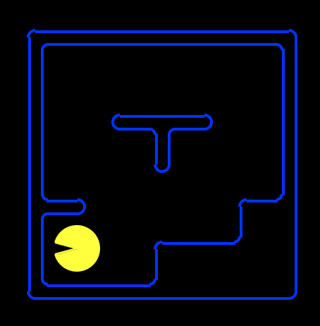
Summary of Pacphysics used in Q3 and Q4 (also found at AIMA chapter 7.7):
- For all xx, yy, tt: if there is a wall at (x,y)(x,y), then pacman is not at (x,y)(x,y) at tt.
- For each tt: Pacman is at exactly on of the locations described by all possible (x,y)(x,y). Can be optimized with knowledge of outer or all walls, follow spec for each function.
- For each tt: Pacman takes exactly on of the possible actions.
- For each tt (except for tt = ??), transition model: Pacman is at (x,y)(x,y) at tt if and only if he was at [join with or, over all possible dx,dydx,dy: (x−dx,y−dy)(x−dx,y−dy) at t−1t−1 and took action (dx,dy)(dx,dy) at t−1t−1].
Note that the above always hold true regardless of any specific game, actions, etc. To the above always-true/ axiom rules, we add information consistent with what we know.
Debugging hints:
- If you’re finding a length-0 or a length-1 solution: is it enough to simply have axioms for where Pacman is at a given time? What’s to prevent him from also being in other places?
- As a sanity check, verify that if Pacman is at (1,1)(1,1) at time 00 and at (4,4)(4,4) at time 66, he was never at (5,5)(5,5) at any time in between.
- If your solution is taking more than a couple minutes to finish running, you may want to revisit implementation of exactlyOne and atMostOne, and ensure that you’re using as few clauses as possible.

Q5 (3 points): Eating All the Food
Pacman is trying to eat all of the food on the board. Implement the following method using propositional logic to plan Pacman’s sequence of actions leading him to the goal.
- foodLogicPlan(problem): Given an instance of logicPlan.PlanningProblem, returns a sequence of action strings for the Pacman agent to execute.
This question has the same general format as question 4; you may copy your code from there as a starting point. The notes and hints from question 4 apply to this question as well. You are responsible for implementing whichever successor state axioms are necessary that were not implemented in previous questions.
What you will change from the previous question:
- Initialize Food[x,y]_tFood[x,y]_t variables based on what we initially know using the code PropSymbolExpr(food_str, x, y, time=t), where each variable is true if and only if there is a food at (x,y)(x,y) at time tt.
- Change the goal assertion: your goal assertion sentence must be true if and only if all of the food have been eaten. This happens when all Food[x,y]_tFood[x,y]_t are false.
- Add a food successor axiom: what is the relation between Food[x,y]_t+1Food[x,y]_t+1 and Food[x,y]_tFood[x,y]_t and Pacman[x,y]_tPacman[x,y]_t? The food successor axiom should only involve these three variables, for any given (x,y)(x,y) and tt. Think about what the transition model for the food variables looks like, and add these sentences to your knowledge base at each timestep.
Test your code using:
python pacman.py -l testSearch -p LogicAgent -a fn=flp,prob=FoodPlanningProblem
We will not test your code on any layouts that require more than 50 time steps.
To test and debug your code run:
python autograder.py -q q5

Helper Functions for the rest of the Project
For the remaining questions, we will rely on the following helper functions, which will be referenced by the pseudocode for localization, mapping, and SLAM.
Add pacphysics, action, and percept information to KB
- Add to KB: pacphysics_axioms(...), which you wrote in q3. Use sensorAxioms and allLegalSuccessorAxioms for localization and mapping, and SLAMSensorAxioms and SLAMSuccessorAxioms for SLAM only.
- Add to KB: Pacman takes action prescribed by agent.actions[t]
- Get the percepts by calling agent.getPercepts() and pass the percepts to fourBitPerceptRules(...) for localization and mapping, or numAdjWallsPerceptRules(...) for SLAM. Add the resulting percept_rules to KB.
Find possible pacman locations with updated KB
- possible_locations = []
- Iterate over non_outer_wall_coords.
  - Can we prove whether Pacman is at (x,y)(x,y)? Can we prove whether Pacman is not at (x,y)(x,y)? Use entails and the KB.
  - If there exists a satisfying assignment where Pacman is at (x,y)(x,y) at time tt, add (x,y)(x,y) to possible_locations.
  - Add to KB: (x,y)(x,y) locations where Pacman is provably at, at time tt.
  - Add to KB: (x,y)(x,y) locations where Pacman is provably not at, at time tt.
  - Hint: check if the results of entails contradict each other (i.e. KB entails AA and entails ¬A¬A). If they do, print feedback to help debugging.
Find provable wall locations with updated KB
- Iterate over non_outer_wall_coords.
  - Can we prove whether a wall is at (x,y)(x,y)? Can we prove whether a wall is not at (x,y)(x,y)? Use entails and the KB.
  - Add to KB and update known_map: (x,y)(x,y) locations where there is provably a wall.
  - Add to KB and update known_map: (x,y)(x,y) locations where there is provably not a wall.
  - Hint: check if the results of entails contradict each other (i.e. KB entails AA and entails ¬A¬A). If they do, print feedback to help debugging.
Observation: we add known Pacman locations and walls to KB so that we don’t have to redo the work of finding this on later timesteps; this is technically redundant information since we proved it using the KB in the first place.

Q6 (4 points): Localization
Pacman starts with a known map, but unknown starting location. It has a 4-bit sensor that returns whether there is a wall in its NSEW directions. For example, 1001 means there is a wall to pacman’s North and West directions, and these 4-bits are represented using a list with 4 booleans. By keeping track of these sensor readings and the action it took at each timestep, Pacman is able to pinpoint its location. You will code up the sentences that help Pacman determine the possible locations it can be at each timestep by implementing:
- localization(problem, agent): Given an instance of logicPlan.LocalizationProblem and an instance of logicAgents.LocalizationLogicAgent, repeatedly yields for timesteps t between 0 and agent.num_steps-1 a list of possible locations (xi,yi)(xi​,yi​) at tt: [(x_0_0, y_0_0), (x_1_0, y_1_0), ...]. Note that you don’t need to worry about how generators work as that line is already written for you.
For Pacman to make use of sensor information during localization, you will use two methods already implemented for you. sensorAxioms – i.e. Blocked[Direction]_t↔[(P[xi,yj]_t∧WALL[xi+dx,yj+dy])∨(P[xi′,yj′]_t∧WALL[xi′+dx,yj′+dy])...]Blocked[Direction]_t↔[(P[xi​,yj​]_t∧WALL[xi​+dx,yj​+dy])∨(P[xi′​,yj′​]_t∧WALL[xi′​+dx,yj′​+dy])...] – and fourBitPerceptRules, which translate the percepts at time tt into logic sentences.
Please implement the function according to our pseudocode:
- Add to KB: where the walls are (walls_list) and aren’t (not in walls_list).
- for t in range(agent.num_timesteps):
  - Add pacphysics, action, and percept information to KB.
  - Find possible pacman locations with updated KB.
  - Call agent.moveToNextState(action_t) on the current agent action at timestep tt.
  - yield the possible locations.
Note on display: the yellow Pacman is where he is at the time that’s currently being calculated, so possible locations and known walls and free spaces are from the previous timestep.
To test and debug your code run:
python autograder.py -q q6

Q7 (3 points): Mapping
Pacman now knows his starting location, but does not know where the walls are (other than the fact that the border of outer coordinates are walls). Similar to localization, it has a 4-bit sensor that returns whether there is a wall in its NSEW directions. You will code up the sentences that help Pacman determine the location of the walls by implementing:
- mapping(problem, agent): Given an instance of logicPlan.MappingProblem and an instance of logicAgents.MappingLogicAgent, repeatedly yields for timesteps t between 0 and agent.num_steps-1 knowledge about the map [[1, 1, 1, 1], [1, -1, 0, 0], ... ] at t. Note that you don’t need to worry about how generators work as that line is already written for you.
- known_map:
  - known_map is a 2D-array (list of lists) of size (problem.getWidth()+2, problem.getHeight()+2), because we have walls around the problem.
  - Each entry of known_map is 1 if (x,y)(x,y) is guaranteed to be a wall at timestep tt, 0 if (x,y)(x,y) is guaranteed to not be a wall, and -1 if (x,y)(x,y) is still ambiguous at timestep tt.
  - Ambiguity results when one cannot prove that (x,y)(x,y) is a wall and one cannot prove that (x,y)(x,y) is not a wall.
Please implement the function according to our pseudocode:
- Get initial location (pac_x_0, pac_y_0) of Pacman, and add this to KB. Also add whether there is a wall at that location.
- for t in range(agent.num_timesteps):
  - Add pacphysics, action, and percept information to KB.
  - Find provable wall locations with updated KB.
  - Call agent.moveToNextState(action_t) on the current agent action at timestep tt.
  - yield known_map
To test and debug your code run:
python autograder.py -q q7

Q8 (4 points): SLAM
Sometimes Pacman is just really lost and in the dark at the same time. In SLAM (Simultaneous Localization and Mapping), Pacman knows his initial coordinates, but does not know where the walls are. In SLAM, Pacman may inadvertently take illegal actions (for example, going North when there is a wall blocking that action), which will add to the uncertainty of Pacman’s location over time. Additionally, in our setup of SLAM, Pacman no longer has a 4 bit sensor that tells us whether there is a wall in the four directions, but only has a 3-bit sensor that reveals the number of walls he is adjacent to. This is sort of like wifi signal-strength bars; 000 = not adjacent to any wall; 100 = adjacent to exactly 1 wall; 110 = adjacent to exactly 2 walls; 111 = adjacent to exactly 3 walls. These 3 bits are represented by a list of 3 booleans. Thus, instead of using sensorAxioms and fourBitPerceptRules, you will use SLAMSensorAxioms and numAdjWallsPerceptRules. You will code up the sentences that help Pacman determine (1) his possible locations at each timestep, and (2) the location of the walls, by implementing:
- slam(problem, agent): Given an instance of logicPlan.SLAMProblem and logicAgents.SLAMLogicAgent, repeatedly yields a tuple of two items:
  - known_map at tt (of the same format as in question 6 (mapping))
  - list of possible pacman locations at tt (of the same format as in question 5 (localization))
To pass the autograder, please implement the function according to our pseudocode:
- Get initial location (pac_x_0, pac_y_0) of Pacman, and add this to KB. Update known_map accordingly and add the appropriate expression to KB.
- for t in range(agent.num_timesteps):
  - Add pacphysics, action, and percept information to KB. Use SLAMSensorAxioms, SLAMSuccessorAxioms, and numAdjWallsPerceptRules.
  - Find provable wall locations with updated KB.
  - Find possible pacman locations with updated KB.
  - Call agent.moveToNextState(action_t) on the current agent action at timestep tt.
  - yield known_map, possible_locations
To test and debug your code run (note: this is slow, staff solution takes 3.5 minutes to run to completion on a good laptop processor):
python autograder.py -q q8

Submission
In order to submit your project upload the Python files you edited. For instance, use Gradescope’s upload on all .py files in the project folder.

